

**SHAID SMARAK COLLEGE**

Kirtipur, Kathmandu

*Lab no: 5 of Digital logics*

**Submitted by :-**

1st semester

Amir Maharjan

**Submitted to :-**

Himal Raj Gental

**LAB 4: DECODER**

**Objective:**

* To understand the concept of encoder.
* To learn how to implement encoder.

**Discussion:**

In general, an encoder is a device or process that converts data from one format to another. In position sensing, an encoder is a device which can detect and convert mechanical motion to an analog or digital encoded output signals.

**Encoder:**

It is a digital circuit that performs the inverse operation of a decoder. It has 2n input lines and n output lines. The output lines generate the binary code corresponding to the input value. An example is the octal-to-binary encoder which has eight inputs, one for each of the octal inputs, and 3 outputs that generate the corresponding binary number. This is the exact opposite of 3-to-8-line decoder.

|  |  |  |  |  |  |  |  |  |  |  |
| --- | --- | --- | --- | --- | --- | --- | --- | --- | --- | --- |
| **Y7** | **Y6** | **Y5** | **Y4** | **Y3** | **Y2** | **Y1** | **Y0** | **A2** | **A1** | **A0** |
| **0** | **0** | **0** | **0** | **0** | **0** | **0** | **1** | **0** | **0** | **0** |
| **0** | **0** | **0** | **0** | **0** | **0** | **1** | **0** | **0** | **0** | **1** |
| **0** | **0** | **0** | **0** | **0** | **1** | **0** | **0** | **0** | **1** | **0** |
| **0** | **0** | **0** | **0** | **1** | **0** | **0** | **0** | **0** | **1** | **1** |
| **0** | **0** | **0** | **1** | **0** | **0** | **0** | **0** | **1** | **0** | **0** |
| **0** | **0** | **1** | **0** | **0** | **0** | **0** | **0** | **1** | **0** | **1** |
| **0** | **1** | **0** | **0** | **0** | **0** | **0** | **0** | **1** | **1** | **0** |
| **1** | **0** | **0** | **0** | **0** | **0** | **0** | **0** | **1** | **1** | **1** |

0Table: *Truth table of 8 to 3 encoder.*

The 8 to 3 encoder or octal to binary encoder consists of 8 inputs i.e. Y7 to Y0 and 3 inputs i.e. A2 to A0. Each input line corresponds to each octal digit and three outputs generate corresponding binary code. The logical expressions of A2, A1, and A0 are as:

A2: Y7 + Y6 + Y5 + Y4

A1: Y7 + Y6 + Y3 + Y2

A0: Y7 + Y5 + Y3 + Y1

**# Example: - 8-to3-line encoder**

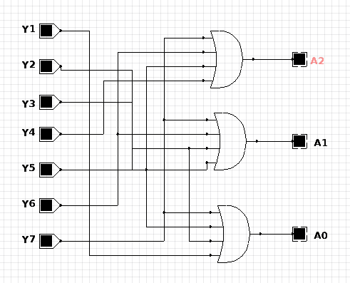

*Fig: 8-to-3-line Encoder*

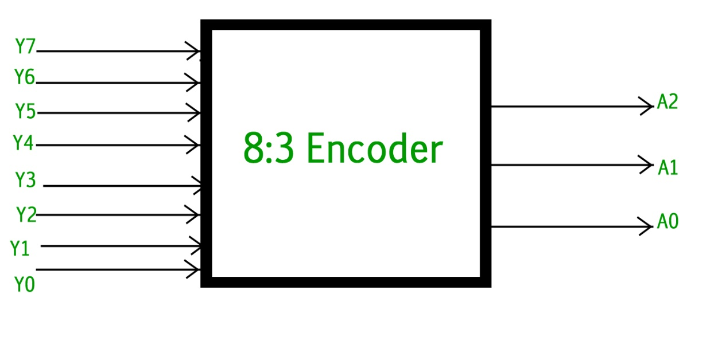

*Fig: Implementation of 8-to-3-line encoder.*

The implementation of 8-to-3-line encoder is not much different than 3-to-8-line decoder, the only difference between the two is encoder has 8 inputs, 3 outputs and decoder has 3 inputs and 8 outputs. Therefore, encoder and decoder are vice versa.